EJB Home Factory

An EJB client needs to lookup an EJB home object, but multiple lookups of the same home are redundant.
How can a client lookup an EJB home only once in the lifetime of its application, and abstract the details of that lookup?
* * *
The JNDI lookup of an enterprise beans home method is the first step to getting access to the remote interface of an EJB. In order to get access to this interface, the client must go through the code intensive and expensive process of getting access to the InitialContext, followed by performing the actual lookup of the EJB home, casting it and handling exceptions, as depicted in the following code:

try //to get the initial context

{
Properties properties = new Properties();

// Get location of name service
properties.put(javax.naming.Context.PROVIDER_URl,
"some providers url");

// Get name of initial context factory
properties.put(javax.naming.Context.INITIAL_CONTEXT_FACTORY, "some name service");

initContext = new InitialContext(properties);
}
catch (Exception e) { // Error getting the initial context ... }

try //to look up the home interface using the JNDI name
{
Object homeObject = initContext.lookup("aHomeName");
myHome = (MyHome) javax.rmi.PortableRemoteObject.narrow(
homeObject, MyHome.class);
}
catch (Exception e) { // Error getting the home interface ... }

//get EJBObject stub
MyEJB anEJB = myHome.create();
The code example illustrates how complex and repetitive EJB home lookups can be. The problem is that a typical application makes use of many EJB home references – one for each EJB a client needs to access. Thus, writing lookup code for each EJB home is essentially duplicate code.
Even worse, once the home is retrieved it is only used once (to get the EJBObject stub) and then not used again. Every JNDI lookup for an EJBHome can be expensive:
Requires a network call if JNDI server is on a different machine. If the client is not collocated on the same machine as the JNDI server, then the call to JDNI will require a network call. An example of when this may occur is in a clustered scenario, where the webserver/servlet engine is on a different box than the EJB Server, where the JNDI server is usually part of the EJB Server.
May Require Inter Process Communication (IPC) if the JNDI server is on the same box. If the client is running on the same box as the EJB server but is not running within the same virtual machine (VM), then there is IPC overhead in looking up an EJB home.
Even if the client (such as a servlet client) is running within the same VM as the JNDI server, looking up an EJB home for every web request can only hurt performance, since an EJBHome never goes stale and can be reused for the lifetime of the client application. Imagine a highly trafficked website (like TheServerSide.com), in which a particular page may be viewed about 500 times per minute. The performance overhead of looking up the same object 500 times for 500 different clients is significant, and completely unnecessary.
A better way is needed to lookup an EJB Home, one that allows lookup code to be abstracted, and one that can reuse the same EJB home instance throughout the life time of the client.
Therefore,
Abstract EJB Home lookup code into a reusable EJB Home Factory, which can cache EJB Homes for the lifetime of a client application.
An EJB Home Factory is a plain java class implemented as a singleton, as in figure X.1. The factory encapsulates EJB Home lookup logic (making this logic reusable for any type of EJB Home) and caches homes internally, passing the cached home to clients upon subsequent requests. An EJB Home factory is reusable across any application as it does not contain any domain specific lookup code, such as getAccountHome, or getXXXHome, rather, it defines a single lookUpHome method. The factory can also be used in any environment, from applets, to servlets, or even between EJB’s, as a method to encapsulate and optimize EJB home lookups.
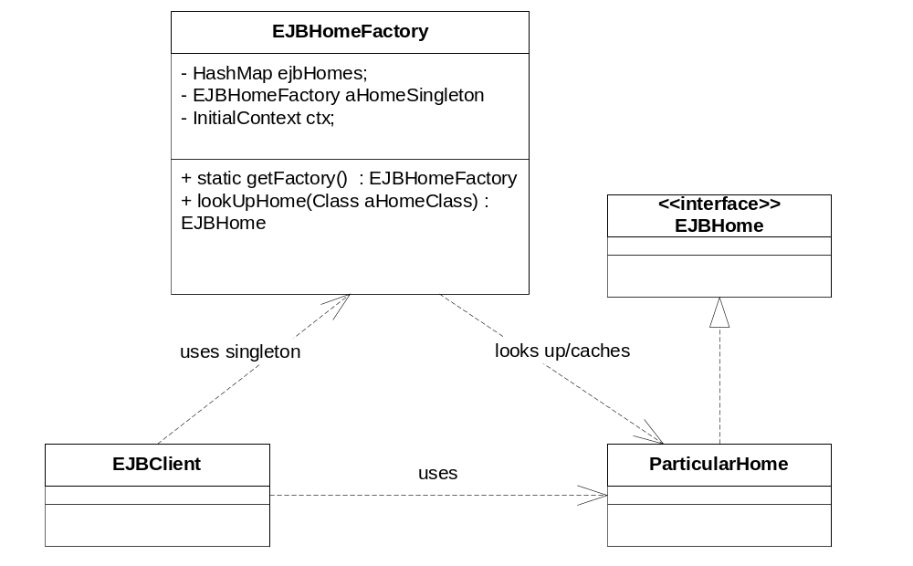
Figure X.1: EJBHomeFactory

A simple implementation of the factory is included in appended X.X.1 (reviewers, see end of this document). Using an EJB Home Factory is simple. A client is completely abstracted from the home lookup and creation logic, reducing client lookup code to just one line. For example, an Account bean client would call the following code (exception-handling code left out for clarity):
A Servlet-centric alternative.
A common practice among Servlet developers is to place EJBHome initialization logic in Servlet.init(), and cache EJBHomes in the ServletContext object, since it is shared across the application. This approach shares the same benefits as EJBHomeFactory (performance, simplicity), but complicates code a bit more. Common presentation layer contructs such as Java Bean helpers do not have access to the ServletContext, and would have to be manually passed one in, in order to get access to an EJB Home. Since the Home Factory is a singleton, it exists anywhere and can thus simplify your code.
AccountHome anAccountHome =
(AccountHome)EJBHomeFactory.getFactory().lookUpHome(AccountHome.class);
Note that the client passes in the .class qualification on the AccountHome interface, instead of a JNDI name. Using the EJB Home Factory, the client is further abstracted from even the JNDI names of the EJB’s. All a client needs to know is the interface of the home object in question (to pass in as a .class parameter, and then to cast the EJBHome returned), but the client needs to use this interface anyway in order to invoke methods on the home object.
The first time a client calls the EJBHomeFactory for a particular home object, the factory will lookup the home through JNDI, and then cache the home object internally in a hashmap. On subsequent calls, the factory will pass out the cached copy of the EJBHome, completely optimizing on home calls.
Here are some implementation requirements for this pattern and sample implementation (provided in the appendix):

JNDI environment entries are refactored to external descriptors. Instead of manually placing hardcoded JNDI Factory and URL strings into a properties object and passing this into the InitialContext constructor (as in the first code example), these properties should be externalized to the clients deployment descriptor or runtime system properties (web.xml for web apps, ejb-jar.xml for ejb’s, the –D flag for a standalone java client, etc). That way, the InitialContext object can find these properties within the System properties automatically at runtime, simplifying the factory implementation and making it more reusable.
A mechanism for JNDI name mappings may need to be created. The sample implementation provided in the appendix assumes that an EJB’s JNDI name is the same as its fully qualified class name (ie: com.xxx.xxxHome). In cases where these names are not possible, JNDI name mappings should be defined in an external descriptor. Within the factories constructor, these environment entries should be converted into .class to JNDI name bindings and stored in another HashMap internally. Alternatively, JNDI name responsibility can be given back to the client by extending the lookUpHome(class) method into lookUpHome(String jndiName, Class aClass);

The EJB Home Factory pattern is a simple and efficient way to abstract EJB Home lookup complexity from the client in a completely generic, reusable format. By caching EJBHomes, performance is increased significantly by eliminating costly redundant home lookups. The EJB Home Factory provides a consistent interface to Home object lookup, and is reusable in any environment (applet, servlet, standalone, even in-between EJB’s).

Appendix X.X.1: Simple EJB Home Cache Factory Example

import javax.ejb.*;
import java.rmi.*;
import java.util.*;
import javax.naming.*;

/**
* EJB Home Factory, maintains a simple hashmap cache of EJBHomes
*/
public class EJBHomeFactory
{
private Map ejbHomes;
private static EJBHomeFactory aFactorySingleton;

Context ctx;

private EJBHomeFactory() throws NamingException
{
//Initialize context with System property Info
ctx = new InitialContext();
this.ejbHomes = Collections.synchronizedMap(new HashMap());
}

/*
* Returns the singleton instance of the EJBHomeFactory
**/
public static EJBHomeFactory getFactory() throws NamingException
{
if ( EJBHomeFactory.aFactorySingleton == null )
{
EJBHomeFactory.aFactorySingleton = new EJBHomeFactory();
}
return EJBHomeFactory.aFactorySingleton;
}

/**
* Lookup and cache an EJBHome object
**/
public EJBHome lookUpHome(Class homeClass) throws NamingException
{
EJBHome anEJBHome = (EJBHome) this.ejbHomes.get(homeClass);

if(anEJBHome == null)
{
anEJBHome = (EJBHome) javax.rmi.PortableRemoteObject.narrow (
ctx.lookup (homeClass.getName()), homeClass);
this.ejbHomes.put(homeClass, anEJBHome);
}
return anEJBHome;
}
}//EJBHomeFactory

